Ramos, Sean Marion R.
21ST CENTURY IT SKILLS - LAB 9
Link to the page: https://personal-showcase--seacheese.replit.app

For this task, I made use of Replit. The initial prompt I made is provided below:
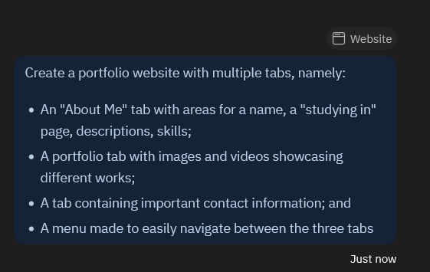
Upon creation, this showed up in the main page:
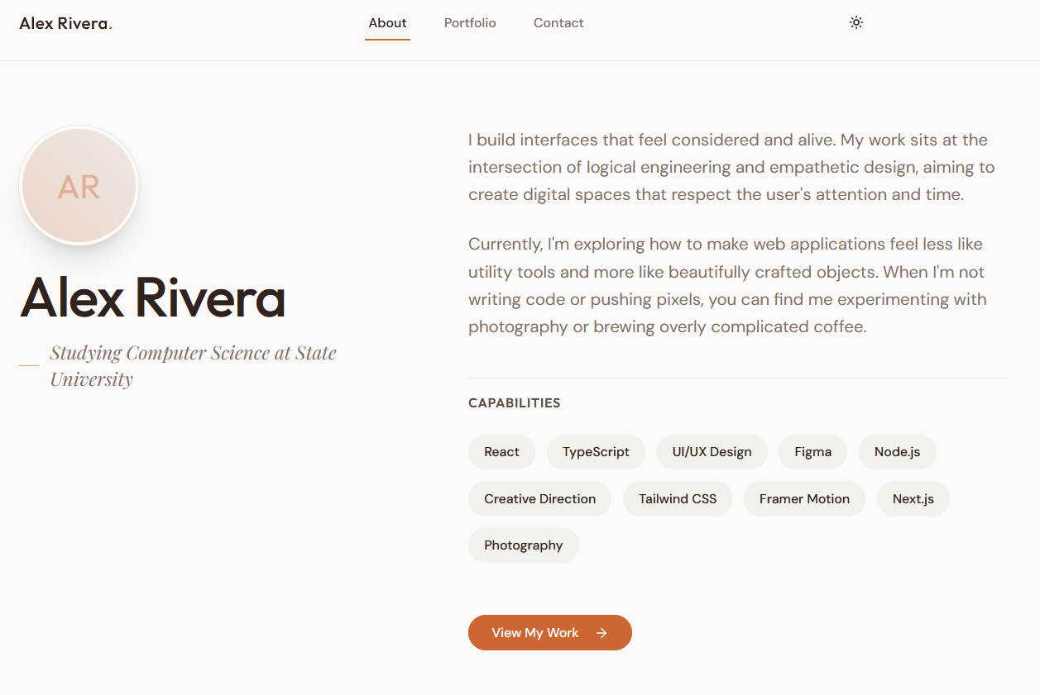
Note that instead of making a menu for navigation, it decided to follow through with the tabs as described.
The subsequent inputs and their outputs are as follows:
REVISION 1
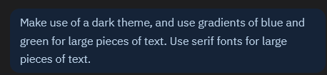
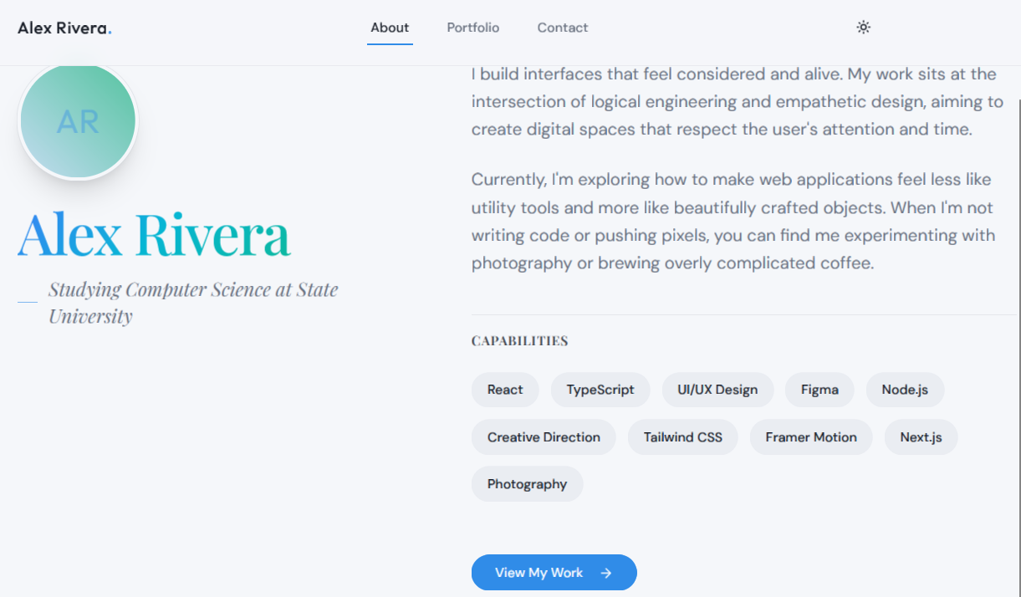
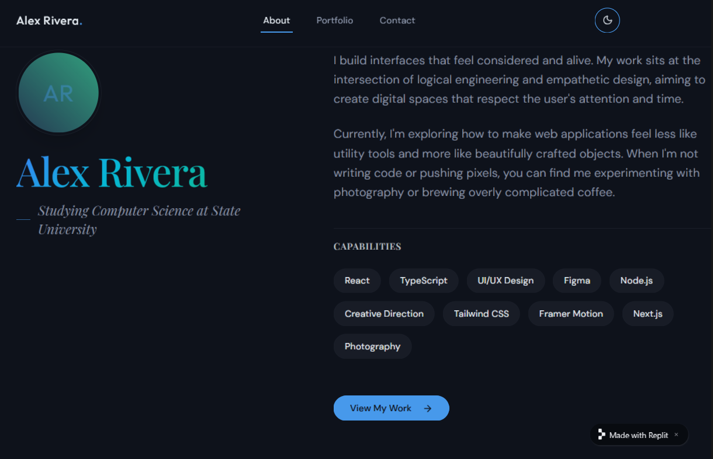
Upon the first revision, I noticed that the UI was not in dark mode by default. Upon closer inspection, it turns out that the AI created a theme toggle beforehand. It seems that sometimes, the AI can make decisions without your input as if those decisions were second nature.
REVISION 2
The next prompt was… a bit more ambitious…
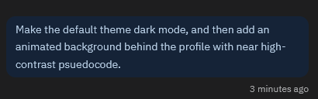
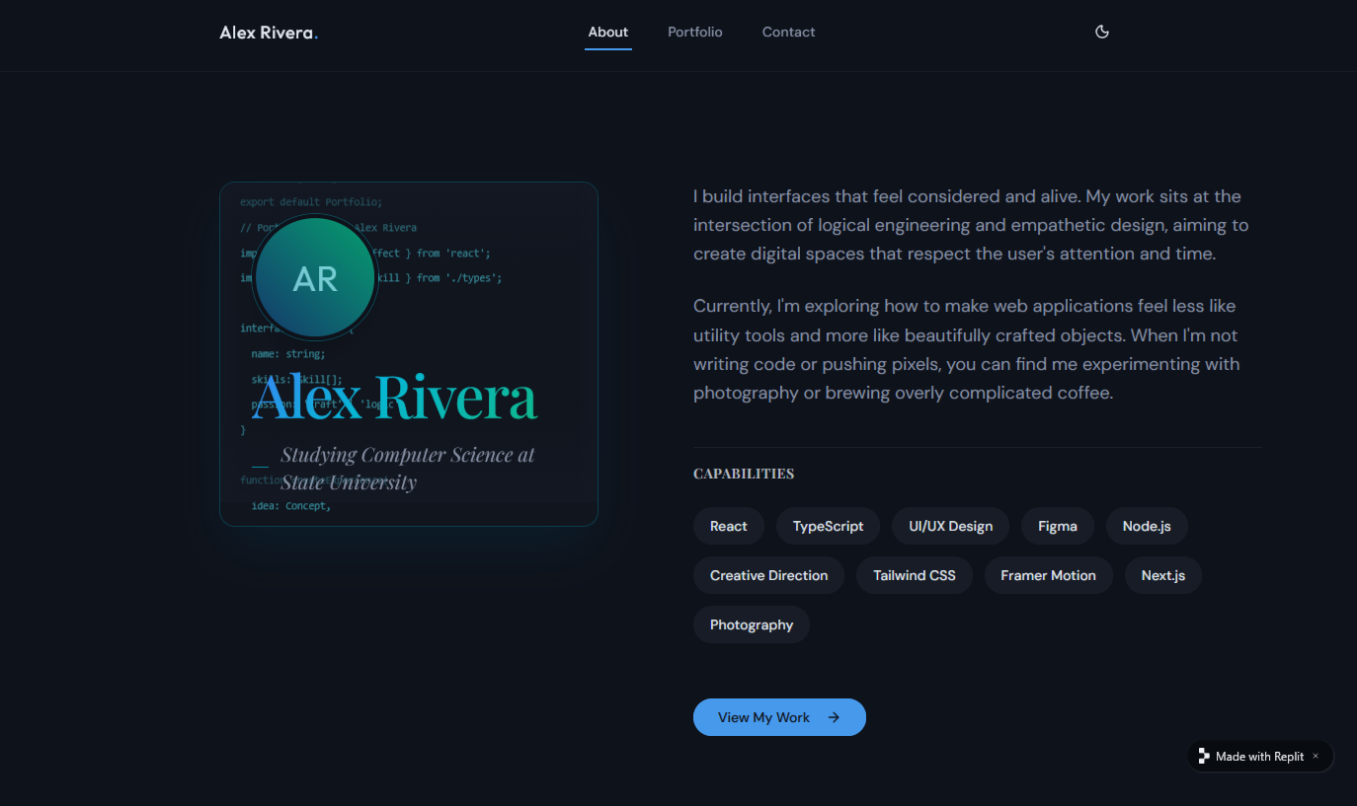
This is how it turned out, but I wanted the code to span the entire screen, so…
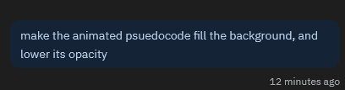
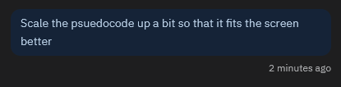
REVISION 3
Two prompts later,
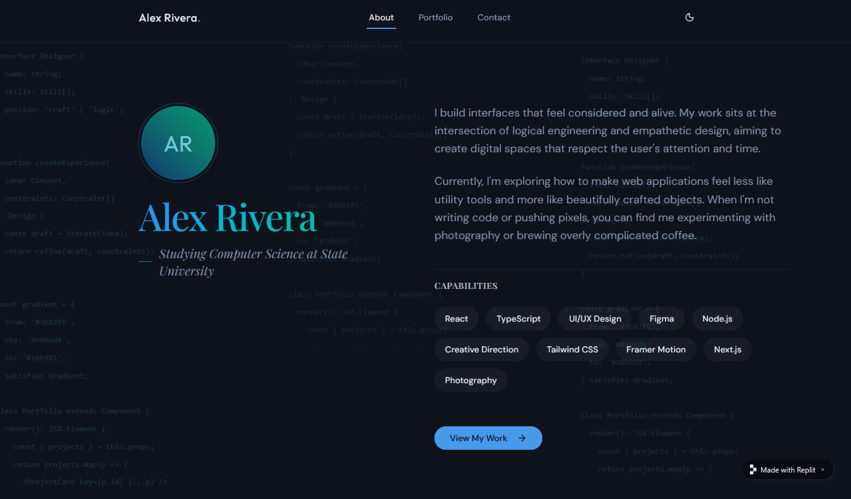

At this point, I’m running out of free credits. I need to make these last changes, pronto!
REVISION 4


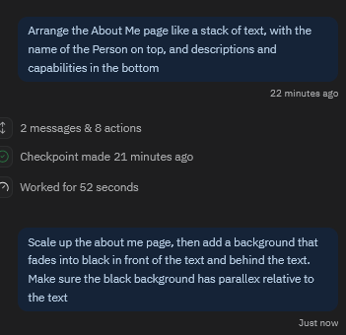
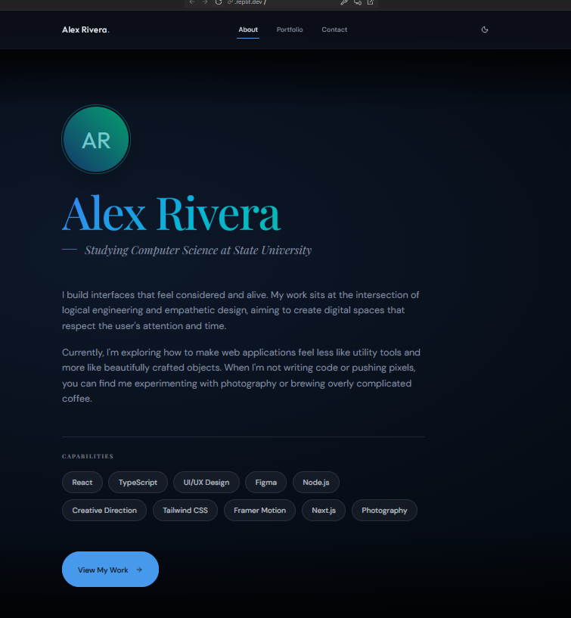
…there goes my credits.

FINDINGS
Prompting a website was something I never considered to do, and is something made much easier with a design tool as easy to use as Replit. Quite potent, I might say. It’s been able to write down almost everything that I asked for through the chat system into the website. I haven’t found a way to build a website with quality like this for so long, until now!
…Though, as much as I’d like to keep working on this, and use Replit to work on various projects of all sorts, the daily limit is immersion-breaking. I might use it less often than I’d want because of that limitation. This is the point where manual fixing comes in, which I haven’t done at all. If I were to fix the project, I’d try to start where the AI stopped, especially with the parallax background.
Something I’ve figured out about prompting is that, similar to real life, you have to speak out your mind sometimes, because not everyone knows what you know. In the case of AI, particularly Replit’s AI, this is somewhat of a reality check, because Replit can make assumptions of what you want, too (the light-dark mode toggle was something I did not requested for.) Context needs to be provided for every feature that you want. And here specifically, since you always have the first say, you have to provide context.
That’s all I can say about prompting so far. What a new experience.

